Set up POP3/IMAP email - Samsung Galaxy S7 Edge
1

Before you start
Make sure you have the following information: 1. Your email address 2. Password 3. Username Internet must be set up before you start this guide.
2

Select Apps
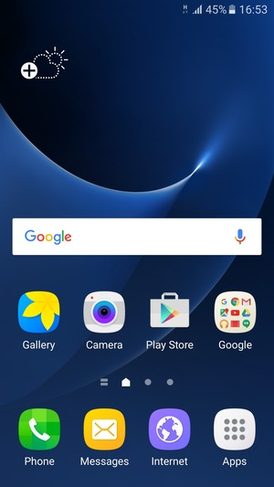
3

Select Samsung
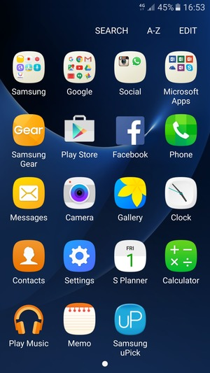
4

Select Email
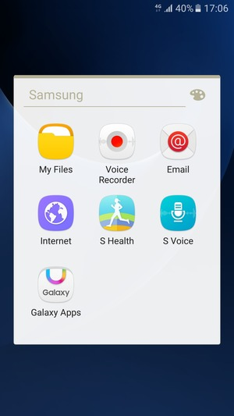
5

Enter your Email address and Password. Select SIGN IN
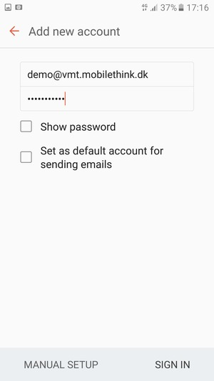
Email address
Password
6

Select POP3 ACCOUNT or IMAP ACCOUNT
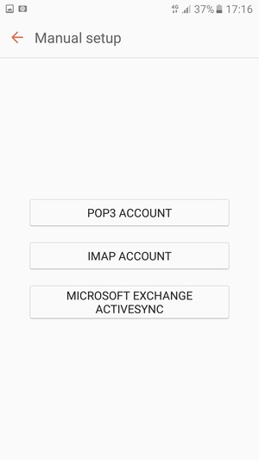
7

Enter User name and Incoming server address
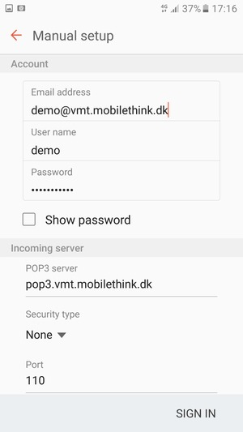
User name
8

Scroll down and enter Outgoing server address
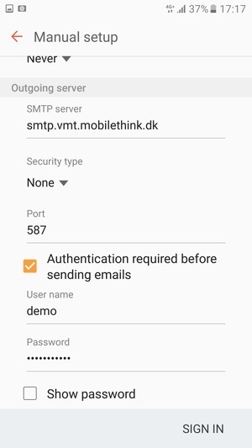
smtp.gprs-connect.dk
9

Uncheck the Authentication required before sending emails checkbox and select SIGN IN
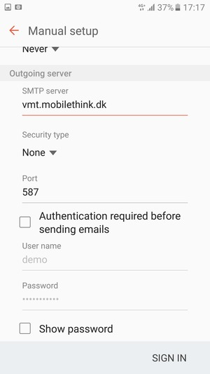
10

Your account is ready to use
